Below are the output screenshots of the application We are going to develop.

We are using the following tools and technologies to develop the same. As mentioned in the description, which we had submitted earlier, we had developed most of the parts except inheriting the service to convert the mails and we are working on creating the test project for which we are facing some issues. We will be finishing those tasks and will update.

1. Visual Studio 2019

2. .NET 4.5 C# MVC

3. Entity Framework 6.0.0

4. Bootstrap 5.4.1

5. Html

6. CSS

7. Javascript

We will update as regularly as possible, similarly as we follow the Agile Methodology.

1. Login Page: I will work on the UI Part, Login Slide 2 and Signup slide 3.

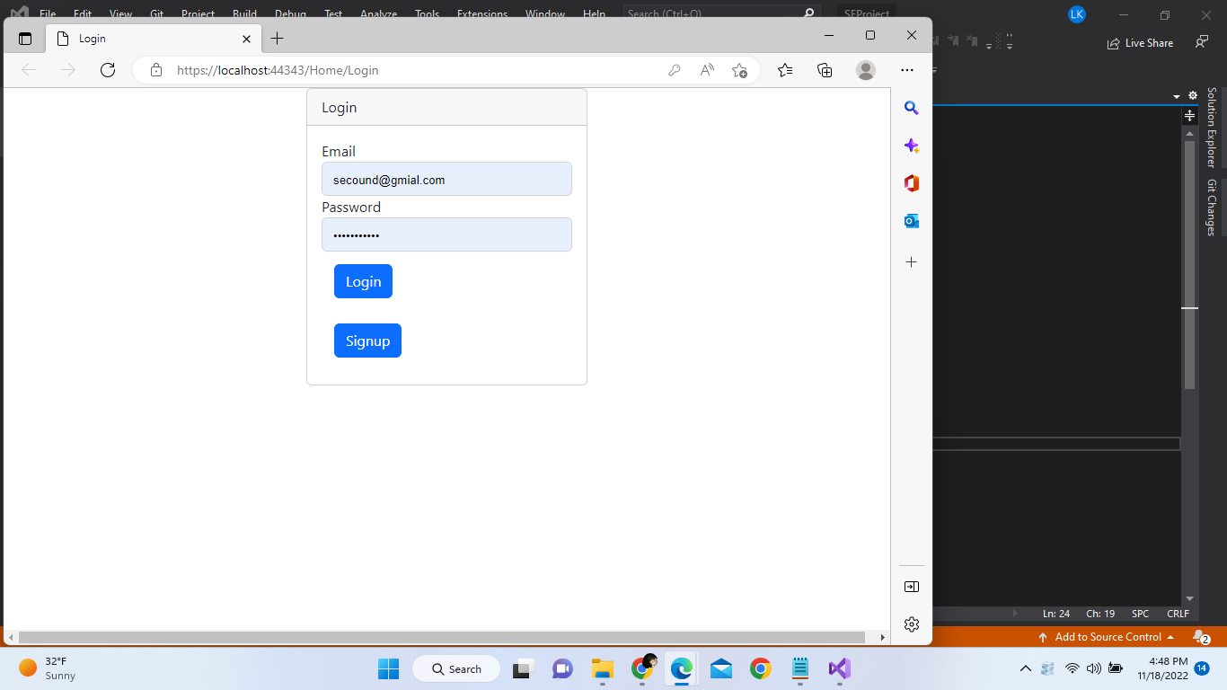

1. Home Page: Need to add the list of all the emails related to user, format, and date fields. Add Emails slde 6. Logout will be moved to Login Page slide 1.

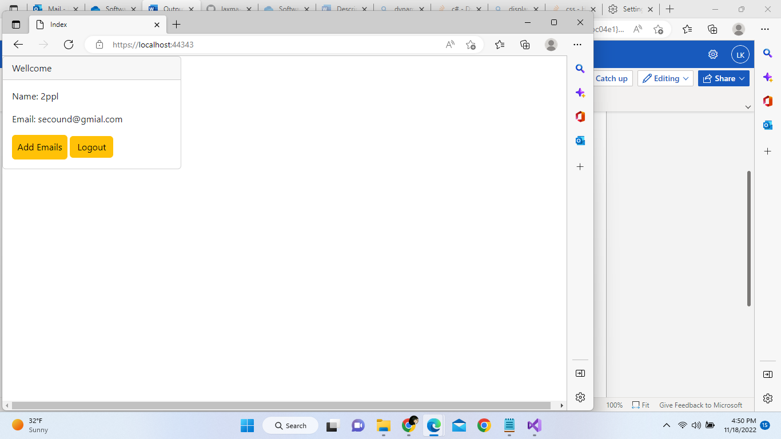

1. Onclick Signup Page from slide 1

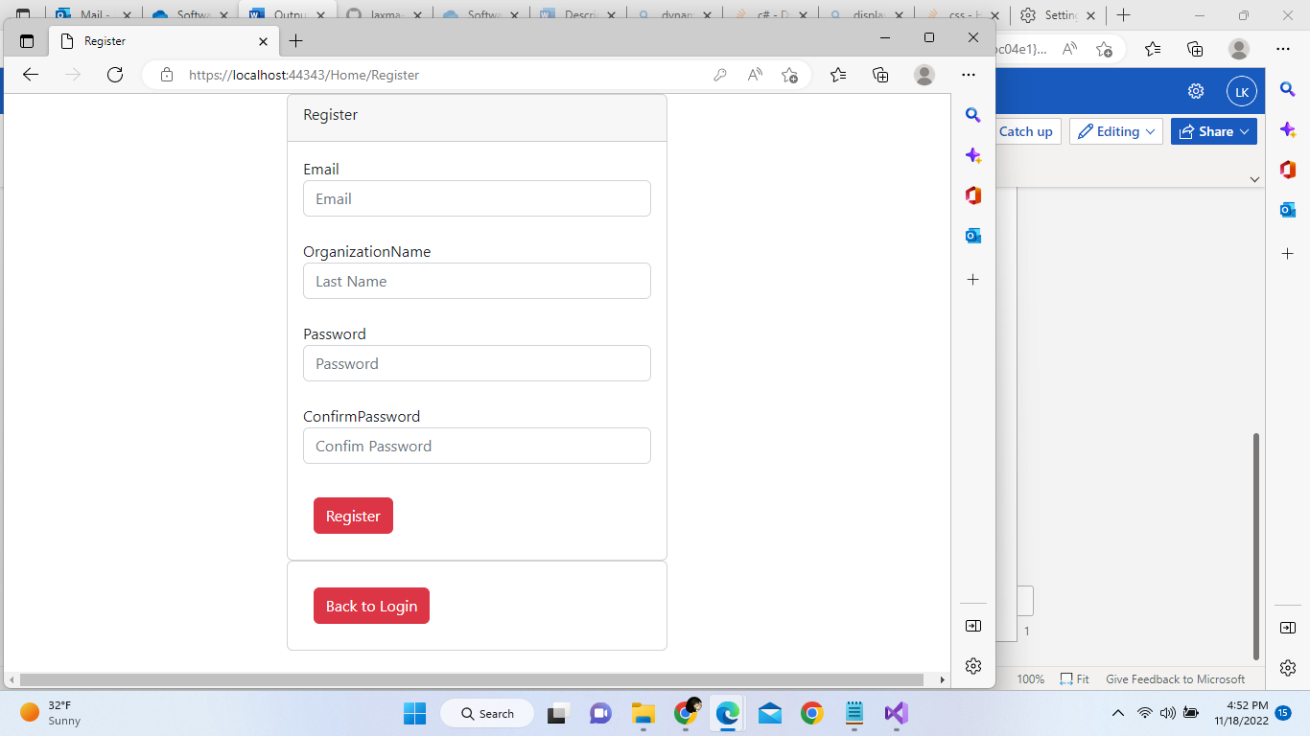

1. Once all the fields are entered correctly, we will be moved to Login page slide 1
2. On Back to Login, we will go to Slide 1 in case we do not want to register and move to Login.
3. From Slide 2 Add Emails will be as below, we can add sub emails to the subscription. For access their inbox.

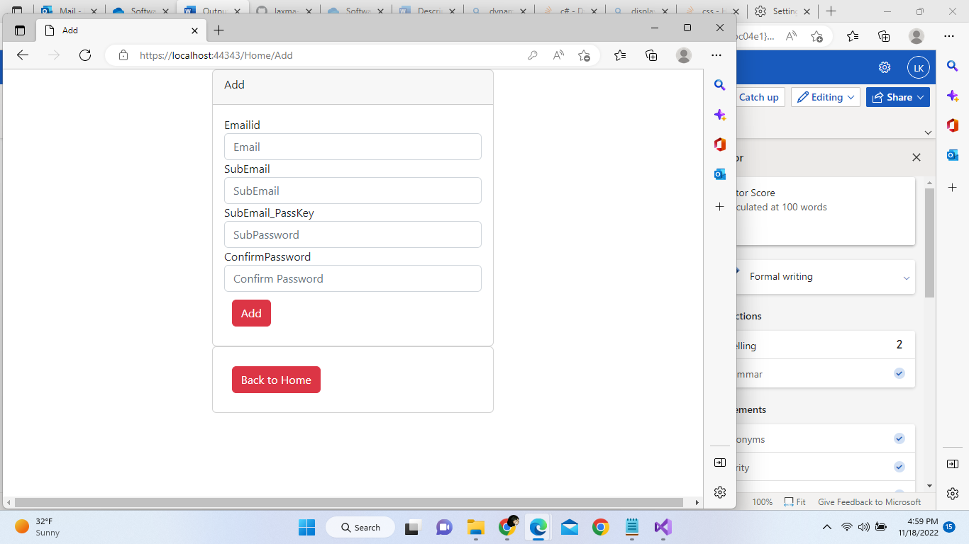

1. Back to Home, will land on slide 2.